Annexure 1: Design of Silaphalakam

- Overview of Silaphalakam
In each panchayat, a memorial plaque of approximately 5 feet x 3 feet is proposed to be erected. (In case any specific space considerations ratio of 5x3 may be maintained accordingly)
- Memorial plaque to be constructed in/around Amrit Sarovar and other water bodies where available. In the places where water bodies are not available, memorial plaques should be constructed near Panchayat offices, schools, etc.
- Work may be executed through the Mahatma Gandhi National Rural Employment Guarantee Act (MGNREGA) leveraging local material and resources.
- Base artwork to be available on the campaign website for reference.
- The print file option would be auto-generated for download basis inputs. (Panchayat Name)

- The design of Silaphalakam would include the following components:
- AKAM Logo
- Prime Minister’s quote for Vision 2047
- Name of Local Veers
- Name of Panchayat
- Date
(Conditions)
- Generic dedication is to be used at the places where Local Veers are not available/applicable
- The downloadable artwork should include AKAM Logo/AKAM 2047 Vision quote/Name of Panchayat and Date
- Downloadable open file should be made available
- Name of the local veers to be added locally

- Definition of ‘Veer’ for the purpose of this initiative
The list of local ‘Veers’ would include:
- Freedom fighters;
- Defense personnel (Army, Navy, Air Force); or
- State Police Forces, Central Armed Police Forces personnel
i.e., people who have died in the line of duty.

- Hon’ble Prime Minister’s quote for Vision 2047
- “To live for the motherland each day, every moment of time and every particle of life will be our true tribute to the freedom fighters.”
Hon’ble Prime Minister Shri Narendra Modi

- Generic dedication quotes
- मातृभूमि की स्वतंत्रता और उसके गौरव की रक्षा के लिये बलिदान हुए वीरों को शत शत नमन।
- Salutations to the heroes who sacrificed their lives to protect the freedom and pride of the motherland.

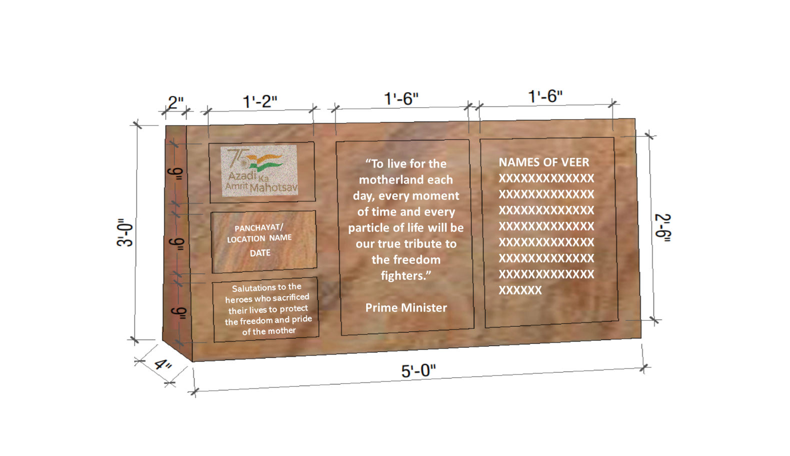
- Design to be used (if Local Veers are available/applicable)

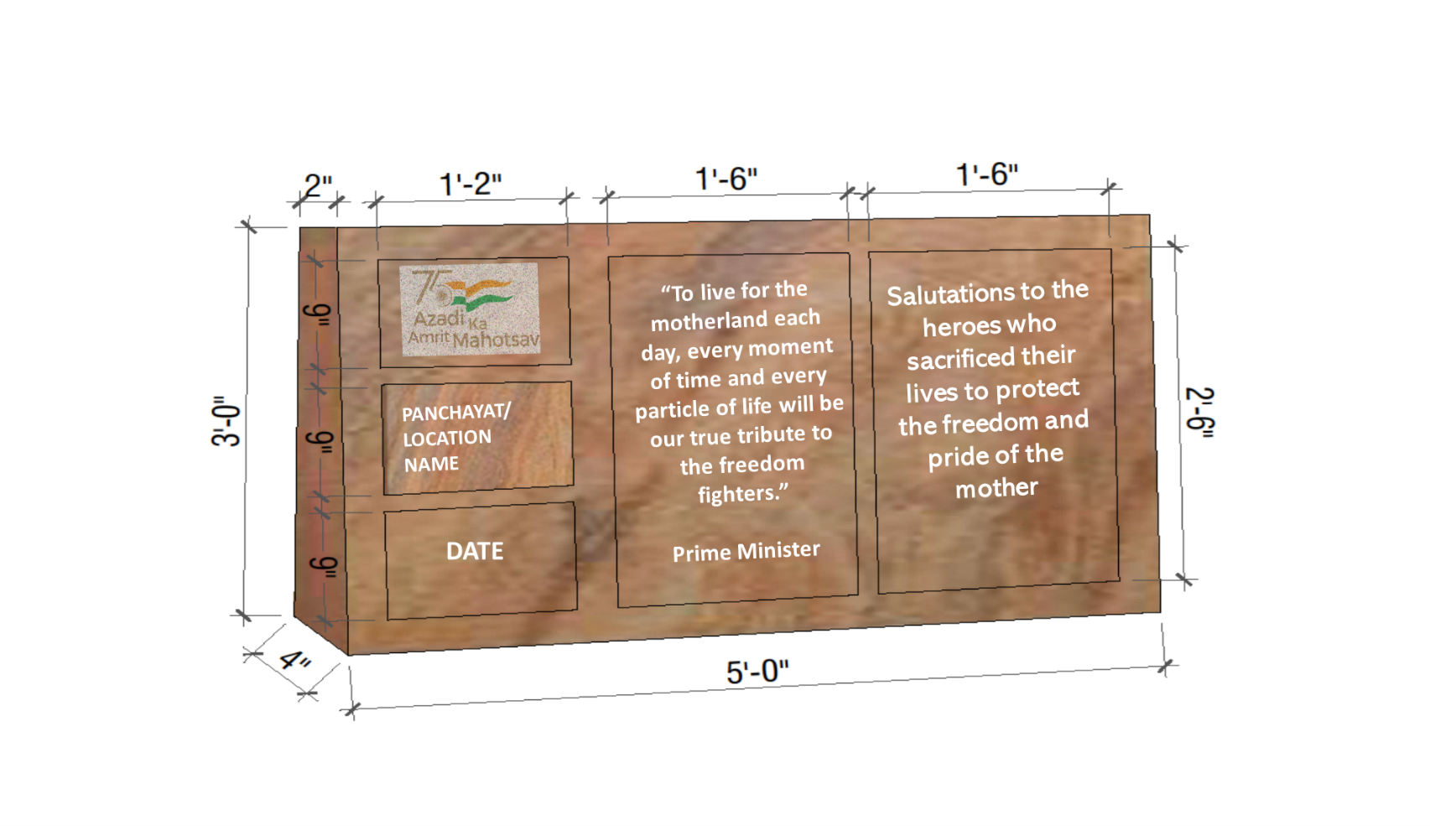
- Design to be used (If Local Veers are not available/applicable)

